Results for commands:

1. print(data.head())

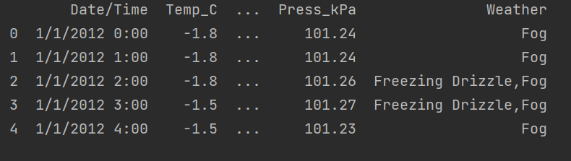

2.print(data.shape)



3. print(data.index)

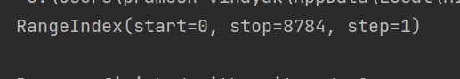

4. print(data.columns)

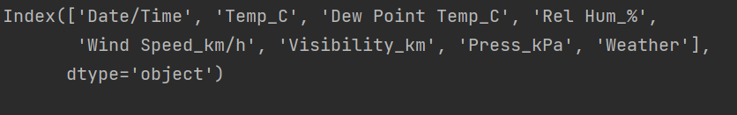

5. print(data.dtypes)

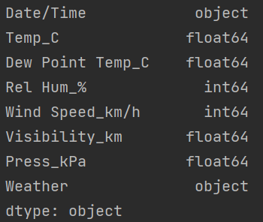

6. print(data['Weather'].unique())

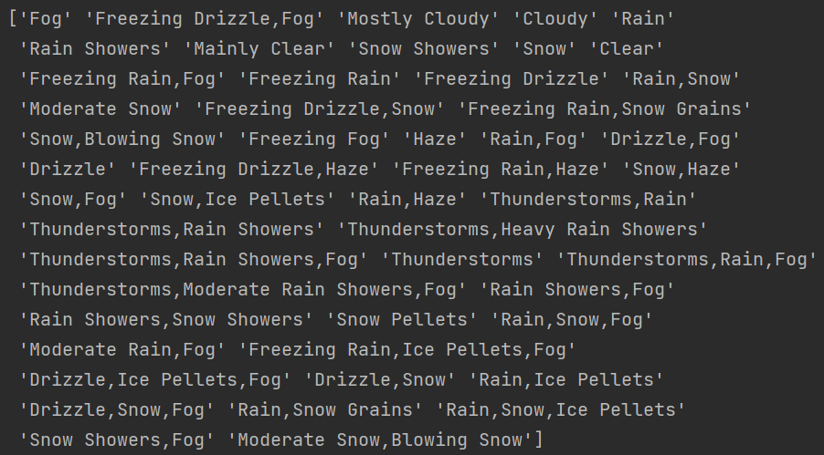

7. print(data.nunique())

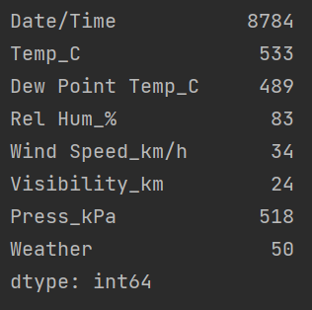

8. print(data.count())

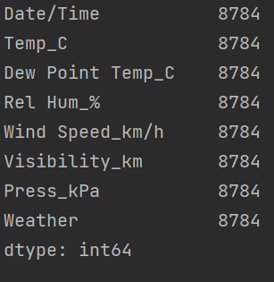

9. print(data['Weather'].value_counts())

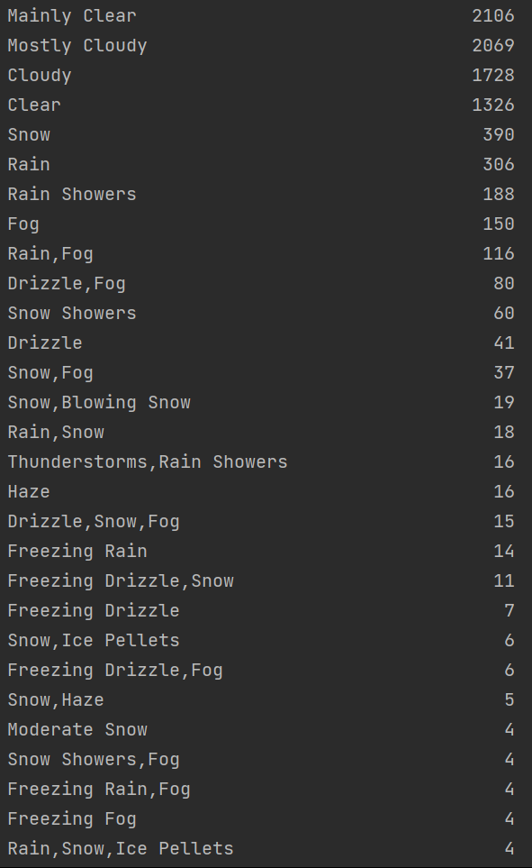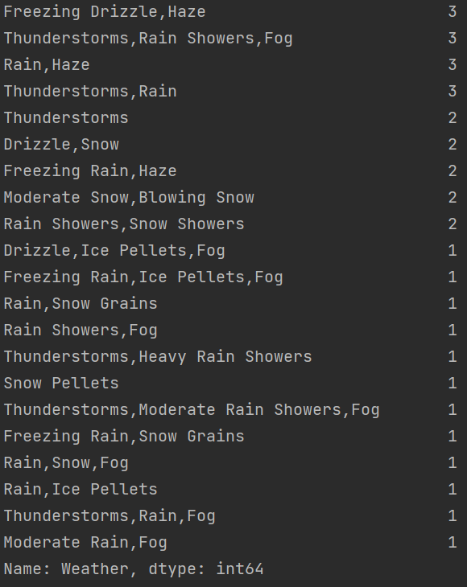

10. print(data.info())

